Batch: D2 Roll No.: 16010221025

Experiment / assignment / tutorial No._______

Grade: AA / AB / BB / BC / CC / CD /DD

Signature of the Staff In-charge with date

**Title:** Jib Crane

CO3: Analyze applications of equilibrium using free body diagram

**Objective**

To calculate the forces in the members of a simple jib crane

**Theory**

A crane is a type of machine, generally equipped with a [hoist](http://en.wikipedia.org/wiki/Hoist_%28device%29), [wire ropes](http://en.wikipedia.org/wiki/Wire_rope) or [chains](http://en.wikipedia.org/wiki/Chain), and [sheaves](http://en.wikipedia.org/wiki/Sheave_%28mechanical%29), that can be used both to lift and lower materials and to move them horizontally. It is mainly used for lifting heavy things and transporting them to other places. It uses one or more [simple machines](http://en.wikipedia.org/wiki/Simple_machine) to create [mechanical advantage](http://en.wikipedia.org/wiki/Mechanical_advantage) and thus move loads beyond the normal capability of a human. Cranes are commonly employed in the [transport](http://en.wikipedia.org/wiki/Transport) industry for the loading and unloading of freight, in the [construction](http://en.wikipedia.org/wiki/Construction) industry for the movement of materials and in the manufacturing industry for the assembling of [heavy equipment](http://en.wikipedia.org/wiki/Heavy_equipment).

**AIM:**

To find the forces in the members of a truss.

**APPARATUS:**

Jib crane apparatus, spring balance, weights, scale, etc.

**Setup Diagram:**

|  |
| --- |
| WALL JIB CRANE | PA Hilton |

**PROCEDURE:**

1. Attach spring balance with BC member.
2. Put weight in pan at C.
3. With the help of scale measure the length of each member.
4. Take the readings on spring balance at members BC and AC and the weight in pan at C.
5. Find the forces in members by analytical calculations and verify the results.

**OBSERVATION TABLE:**

|  |  |  |  |  |
| --- | --- | --- | --- | --- |
| Sr. No. | Weight in Pan  (N) | Length of members (mm) | | |
| AB | BC | AC |
| 1 | 1 | 94 | 93 | 130 |
| 2 | 2 | 94 | 83 | 128 |
| 3 | 3 | 94 | 82 | 127 |

|  |  |  |  |  |  |
| --- | --- | --- | --- | --- | --- |
| Sr. No. | Weight in Pan  (N) | Spring balance reading (N) | | Forces on members (N) | |
| BC | AC | BC | AC |
| 1 | 1 | 1.5 | 1.2 | 1.37 | 0.79 |
| 2 | 2 | 2.6 | 2.2 | 1.15 | 1.74 |
| 3 | 3 | 4 | 3.2 | 2.40 | 2.63 |

**CALCULATION:**

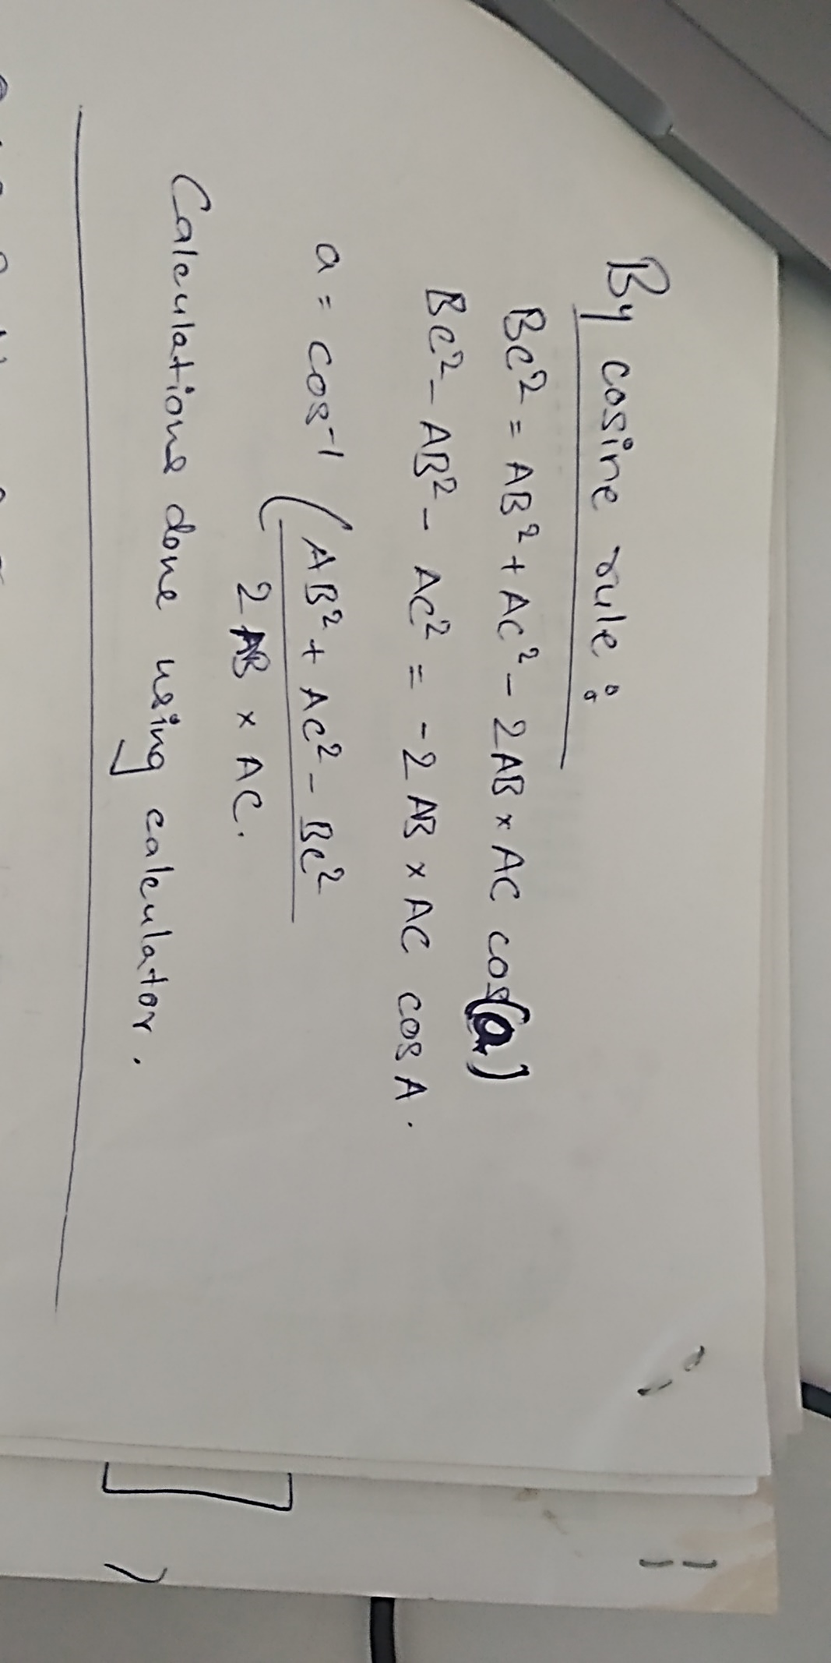

**RESULT:**

Force in Member BC = 21.83N

Force in Member AC = 23N

**Signature of faculty in-charge**